**CS5200 - KITICKET**

**Submitted by – Concept Squad 15**

**Project Description**

**Problem Statement –**

This project is being implemented as part of Course CS5200 Database Management Systems at Northeastern University. The primary goal of this project is to implement a web application which allows users to do an interactive search and make bookings for movies and events. The application will be retrieving all the information pertaining to movies such as Theatre. Location, Movies available, Show times etc. from **International Movies Showtime’s API**

**Proposed Solution –**

Our project is to develop a web-based application that will provide users to browse/register for movies and events based on locations. The website will interact with an API to fetch real-time data about movies that are listed in theatres, their showtimes, available seats, theatres near user and events near user.

A user can make bookings by either registering on the website or as a Guest User. User can further modify the bookings after confirmation and view booking history. Admin will have the authority to implement CRUD operations on the listed movies, theatres, events and user records. Website will allow vendors to register their events on the website along with details such as location, description, seats, pricing etc.

**Domain Objects –**

Each domain object will be interacting with two or more other domain objects (underlined in description)

* **Movie** – A user views a list of movies on the website. The data from the website, location of showtimes, seat availability is retrieved using the API. A user can view a list of movies available at a Theatre**.** User can make a Bookingfor a specific showtime through the website.
* **Booking** – A booking is created once a user proceeds to book a Ticket for Movie/Eventand when thePaymentmade by the user is authorized.
* **Payment** – Once a user selects the seats, he/she can initiate a payment to complete the Booking request. Payment can be made for both Movie and an Event**.** Once payment is authorized, a Ticketis generated by the system.
* **Theatre** – The API responds with a list of Theatres where a Movieis being shown. Each Booking will have a Theatre id selected by the User.
* **Event** – A user views a list of events on the website.User can make a Bookingfor a specific event through the website. The Event id will be mentioned on the Tickets
* **Ticket –** A ticket will be generated for a Booking once the Payment has been confirmed for the same.

**Users –**

Following are the human users in the website –

* **Customer**

Goal – a) Can Login on website

b) Can browse for movies/events based on location.

c) Can create booking for a movie/events

d) Can make payments for a booking

d) Can view booking history

e) Can view/modify its profile details

Relation with User –

Can view vendor details on an event description.

Can contact admin for account issues/feedback.

Relation with Domain Objects –

A Customer can view Movie details on website.

A Customer can vie an Event enlisted on website.

A Customer can create a Booking for a Ticket by making a Payment

* **Guest**

Goal – a) Can browse for movies/events based on location.

b) Can create booking for a movie/events by authorized payment.

c)Can register on website.

Relation with User –

Can view vendor details on an event description.

Can contact admin for account issues/feedback

Relation with Domain Objects –

A Guest can view Movie details on website.

A Guest can view an Event enlisted on website.

A Guest can create a Booking for a Ticket by making a Payment

* **Admin**

Goal – a) Can do CRUD operations on listed movies

b) Can do CRUD operations on listed events

c) Can do CRUD operations on registered users and vendors

Relation with User –

Can view/remove registered vendor details.

Can view/remove registered Customer details.

Relation with Domain Objects –

Can View/Remove listed Movies.

Can View/Remove listed Events.

Can view payment details of all bookings

* **Vendor**

Goal – a) Can Register/Login on website

b) Can enlist an event along with event/payment details

c) Can modify the enlisted events by them

Relation with User –

Can view customer details on the booking made by a customer for an event.

Can contact admin for account issues/feedback

Relation with Domain Objects –

Can enlist an Event on the website.

Can view the list of Bookings made for the event enlisted by them.

Each 2 relations with other user, 2 relations with domain objects

**Movie API -**

Following APIs will be used in the project

* International Movie Showtimes API – It’s an API to fetching real-time data international showtime listings based on location, ticketing links, list of theatres, list of movies, meta data on movies. It’s a free API providing comprehensive movie meta data such as: Synopsis, Runtimes, Trailers, Posters, Movie stills, Ratings, Release Dates, Cast or Genre. It matches details with all relevant industry IDs like: IMDb, TMDb, OMDb, rotten tomatoes, meta critic, IVA, preview networks, krankikom. It is easy to use, accurate and has a fast-responsive time to accommodate huge number of requests in a short span of time.

**Design**

**Class Diagaram -**

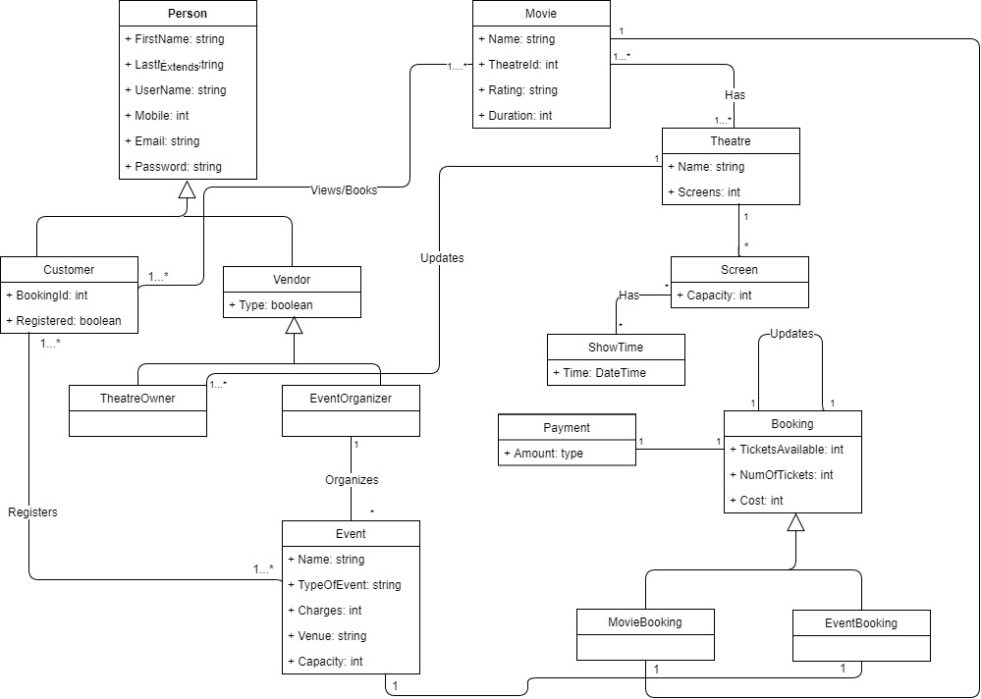

Figure Class Diagram

**Sequence Diagram -**

sjafhdghjd